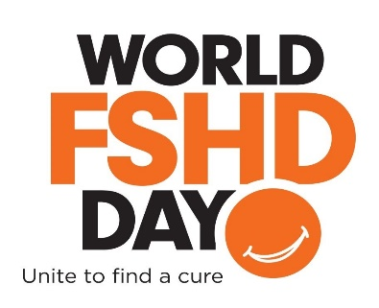
Social Media Promotion

Social media is a fast way to spread news! Help raise awareness about FSH Muscular Dystrophy through your own social media channels. Here are some ideas to make it easy:

Facebook posts:
- Mark your calendars! June 20th is #WorldFSHDday! Learn more about this most common form of #musculardystrophy at www.fshfriends.org.
- Print your orange slice selfie and post a photo of yourself with your “orange slice smile” with a caption saying “Wearing my orange slice selfie in honor of all those with #FSHD who cannot smile”
- Join me in supporting over ½ million people suffering from #FSHD. Go to www.fshfriends.org and join their circle of friends to further research in pursuit of a cure!

Tweets on Twitter:
- Mark your calendars! June 20th is #WorldFSHDday to unite everyone across the globe to support @FSHresearch for a cure!
- Print your orange slice selfie and post a photo of yourself with your “orange slice smile” with a caption saying “In honor of all those with #FSHD who cannot smile. @FSHresearch = a cure = smiles!”
- Join me and post your own orange slice selfie for #WorldFSHDday. Print one out at www.fshfriends.org/blog/world-fshd-day-awards-reception/
- What if you were diagnosed with a disease that had no treatment or cure? Be part of the solution and invest in a cure through @FSHresearch

Instagram Posts:
- Print your orange slice selfie and post a photo of yourself with your “orange slice smile” with a caption saying “In honor of all those with #FSHD who cannot smile. Join @FSHfriendsorg in pursuit of a cure!”
- What if you were diagnosed with a disease that had no treatment or cure? Be part of the solution and invest in a cure through @FSHfriendsorg.

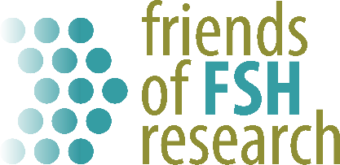
In Pursuit of a Cure
www.fshfriends.org

