2024 Gala Dinner & Auction – February 3, 2024
Presented by Friends of FSH Research
INV #  (Office use only) |  | Email: auction@fshfriends.org Web: www.FSHfriends.org
Donor or Company Name for Catalog: |  |  |  | Fair Market Value: |  | CAT # (Office use only)
Donor Contact Person:  Address:  Phone:  Email:  Website: |  |  |  | TANGIBLE ITEM  DELIVERY BY DONOR or  PICK-UP BY AUCTION OFFICE REP  Delivery or Pick-up Date: ______________________  INTANGIBLE ITEM  DONOR TO PROVIDE CERTIFICATE or  AUCTION STAFF TO CREATE CERTIFICATE
 |  |  |  | PLEASE SEND ME AN INVITATION TO THE AUCTION
Item description for catalog – Include size, color, how many people, time restrictions, special conditions, limitations, etc.:

 |  |  |  |  | EXPIRATION DATE:
DATE: | Donor Signature: |  | Solicitor Name: |  | CERTIFICATE #:
217 19th Place; Kirkland, WA 98033 Phone: 425-827-8954 Tax ID 86-1108537
Every dollar raised from your donation goes to fund FSH research!

Please fill out and return the above form.
A letter of acknowledgement will be sent to you for your records
.

Thank you for your generous donation!

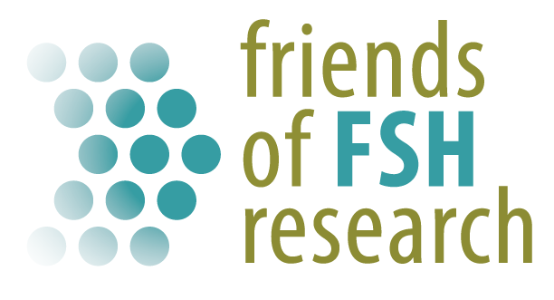

Help us accelerate FSH muscular dystrophy research toward a treatment or cure.

